Assignment 15.1 (multiple inheritance in Scala)

Program to show multiple inheritance in scala.

Step1: Creating ‘trait’ called worker
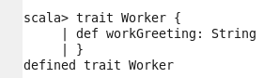

Step2: Creating class called Linguist
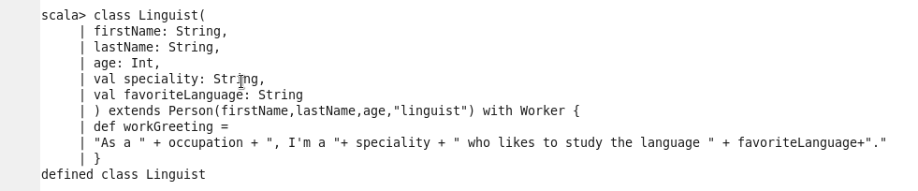

Step3: Creating class called Student
